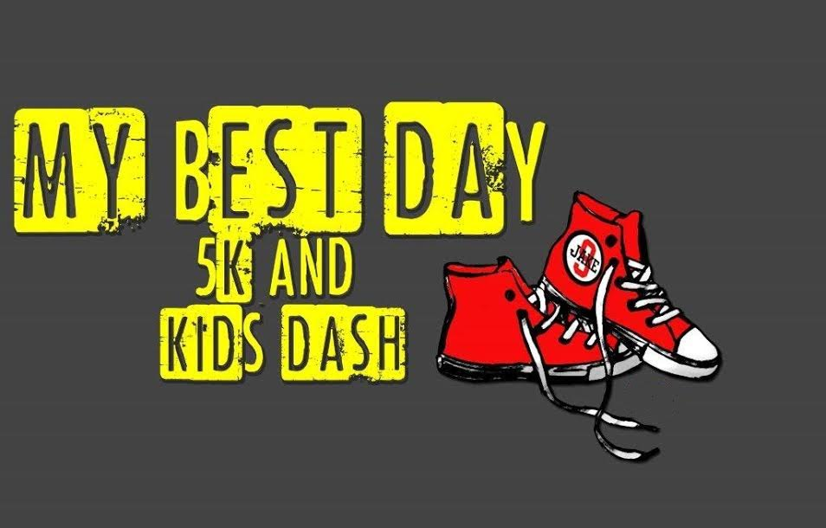
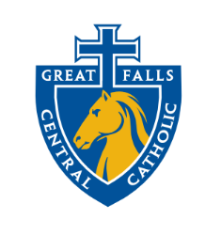
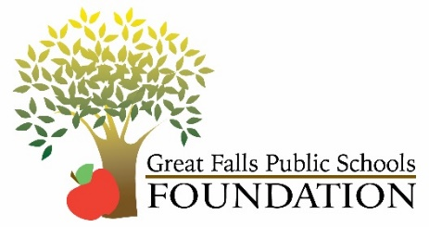
Great Falls, Montana, Sunday, September 11th, 2022
About the event
My Best Day 5k and Kids’ Dash is a fundraiser for the Jake Arntson Memorial Fund. Please join us as we celebrate the life and memory of Jake, as well as other local children and adults that have left us too soon. As we honor these families with their loved ones on Angel Avenue, we are raising funds for the Jake Arntson Teammate of the Year Scholarships. These scholarships are awarded to CMR, GFHS, and GF Central student-athletes that have displayed the qualities of being the best teammate.

Make Checks Payable to GFPS Foundation or Great Falls Central Catholic High School.
Mail to A & F, P.O. Box 3008, GF, MT 59403 or deliver to Peak West Bank Landing
Questions contact:
Jason at 406-855-5112 or jbliss@spfenergy.com
Joanie Agamenoni at 406-781-7739 or joanie.agamenoni@gmail.com
Schedule of Events
11:30 to 12:45 Registration/Packet Pick-up at West Bank Park on
River’s Edge Trail (Branch Brady Statue)
12:45 to 12:55 National Anthem and America the Beautiful
12:55 to 1:00 Warm-ups
1:00 to 1:30 Kids’ Dash CHANCE TO WIN A NEW BIKE
1:30 to 1:40 Walk down Angel Avenue to start of 5K Race
1:40 to 3:00 5K Race

Kids’ Dash
The kids will have an opportunity to show their stuff. The starting line will be at West Bank Park by the Branch Brady statue. There will be two races: one lap (1/4 mile) or two laps (1/2 mile). Kids are welcome to participate in either one or both.
The winners (one boy and one girl) of the 1/2 mile race will win a bike donated by Walmart.

My Best Day Course
All on River’s Edge Trail, loop around the river. Participants will stage at the finish line of the Kids’ Dash by the Branch Brady statue and walk down Angel Avenue to the starting line at the Federal Courthouse. You will cross over the Central Avenue walking bridge. At the end of the bridge, take a left onto River’s Edge Trail heading towards Gibson Park. You will cross River Road at the designated spot, which will be manned. At the skate park, you will continue on the trail towards 9th Street Bridge, cross the 9th Street Bridge and turn left to continue on the trail towards the finish line at West Bank Park. Water/aid station at the half-way point.

-------------------------------------------------------------------------------------------------------------------------------------My Best Day 5k and Kids’ Dash Registration Form
NAME: | DATE OF BIRTH:
STREET ADDRESS: | EMAIL ADDRESS/PHONE NUMBER
METHOD OF PAYMENT/AMOUNT | EMERGENCY CONTACT AND NUMBER

Event:
___5k Run/Walk Adult- $25
___5k Run/Walk Student (18 and under)- $20 ___¼ and/or ½ Mile Kid’s Dash- $15
Additional Donation $______________
MAIL BY AUGUST 26TH TO ENSURE T-SHIRT.
Circle one:
Adult S Adult M Adult L Adult XL Adult XXL
Youth S Youth M Youth L

Waiver and Release
I know that participating in an organized athletic event is potentially hazardous, and that I should not enter to participate unless I am medically able and properly trained. I hereby assume the risks of participating in this event. I certify that I am physically fit and that I have sufficiently trained. I agree to abide by the competitive rules. I hereby take the following action for myself, my executors, administrators, heirs, next to kin, successors and assigns, or anyone else who might claim or sue on my behalf, and I hereby waive, release and discharge from any and all claims, losses, or liabilities for death, personal injury, partial or permanent disability, property damage, medical or hospital bills, or theft which may arise out of or relate to my participation in this event. I agree not to sue, and to hold harmless GFPS, GFPSF, Arntson family or any and all persons, sponsors, landlords (members and affiliates), advisors, lenders, property managers, tenants, volunteers, participants or government agencies for any and all claims or liabilities that I have waived, released or discharges herein. ENTRY FEES ARE NON-REFUNDABLE & NON-TRANSFERABLE
I have read and agree to the above waiver and release for the 5K and Kids’ Dash

Signature:

